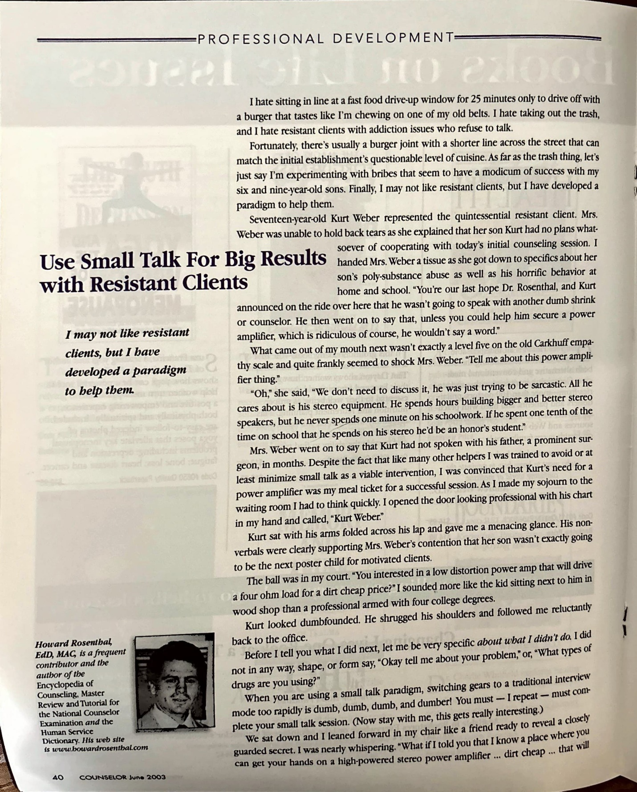

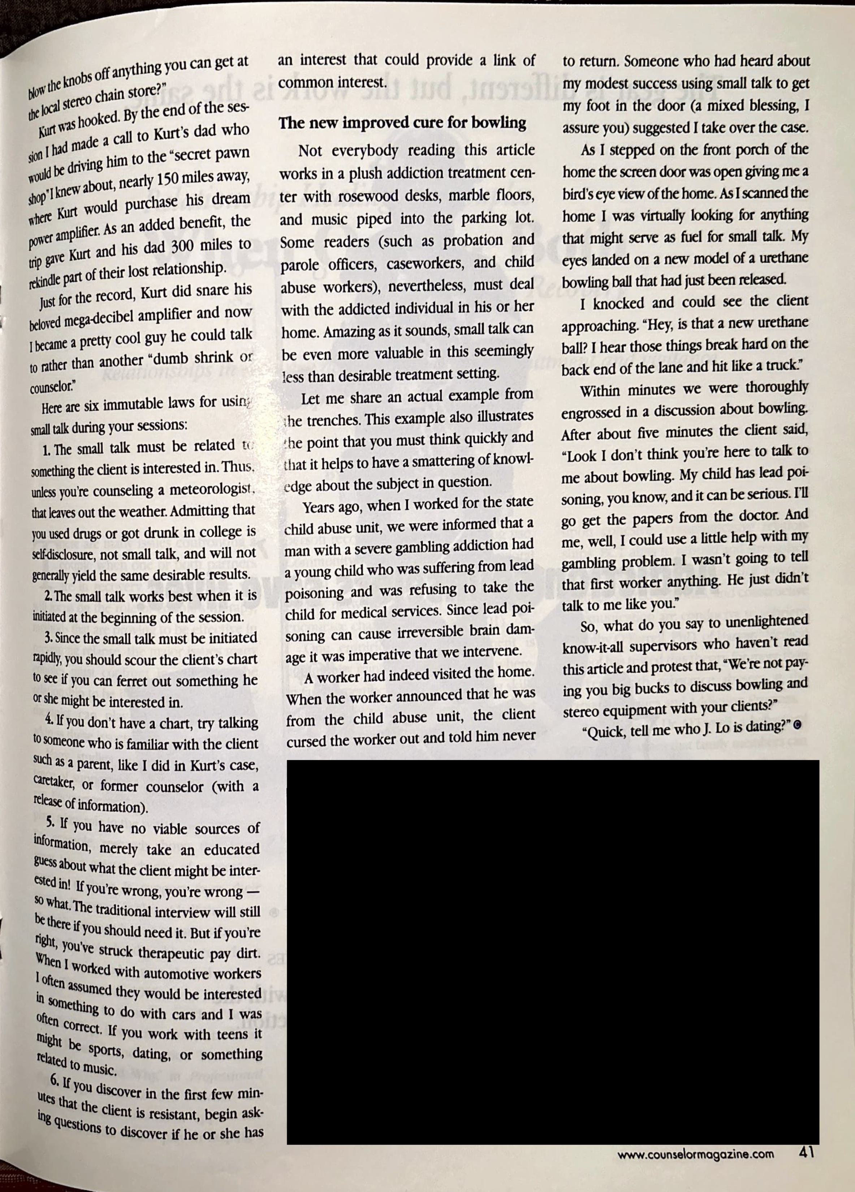

Rosenthal, H. (2003, June). Use small talk for big results with resistant clients. Counselor: The Magazine for Addiction Professionals, 4, 40-41.

