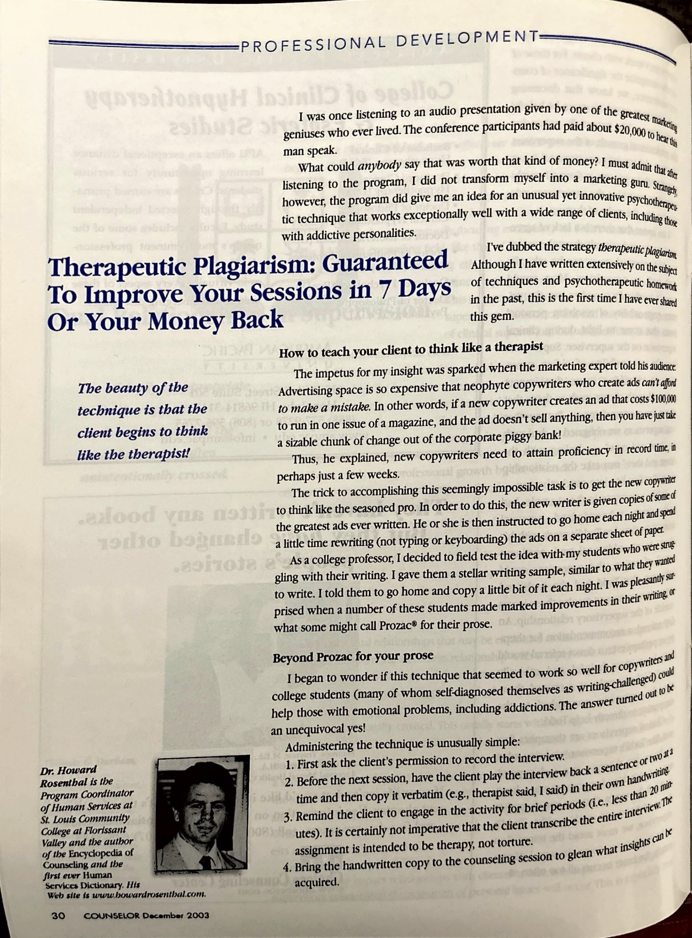
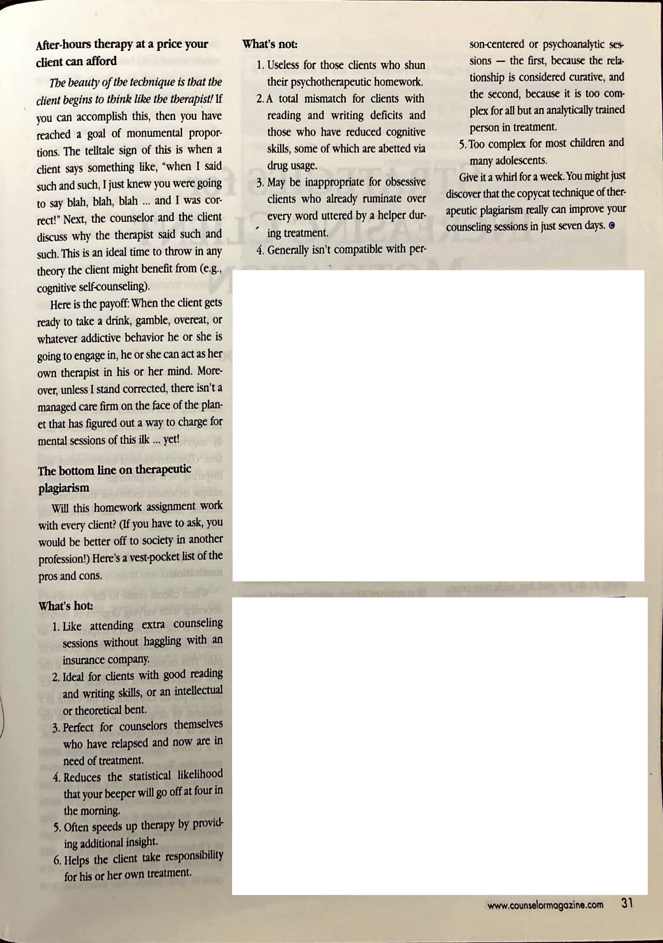
Rosenthal, H. (2003, December). Therapeutic plagiarism: guaranteed to improve your sessions in 7 days or your money back. Counselor: The Magazine for Addiction Professionals, 4, 30-31.

